Name:Mark Fady Kamal ID: 41810042

Assignment 1 ( Task1 , Task2)  
**Documentation (Task1)**  
----------------------------------

* First of all , we need to start with the background color and set it to the green color , so all values in “glClearColor” will be equal zeros except green value(middle) and last value .  
  then Last step Clear the color buffer using “glClear”  
    
  Screenshot from the code:  
  
* Second , Initialize square shape using the (Primitive Functions)   
  ”glBegin(GL_QUADS); Because the quad shape got 4 vertices and the square is 4 vertices shape.   
  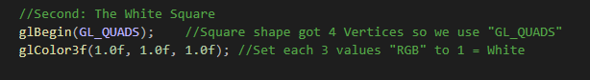
* Third ,Color of the square will be White (as it required for this task) so we must use “glColor” with values of 1 for each to display the white color for the shape .  
  (we will not repeat this step as the shape vertices with same color so we write it only one time)
* Fourth step , Initializing each vertex of the shape   
  giving them a value in float , and start to execute it using “glFlush()”

**Inside The main(2 Tasks are the same):**

* Creating a window to display the output in it (“glutCreateWindows”) then it takes any argument text inside it to rename the label
* After this we can set the size of this windows using (“glutInitWindowSize) taking 2 arguments to set Length and width
* last step we need to Recall the Function we write above ( 4 steps ) using “glutDisplayFunc” which take 1 argument in this case and it is the name of method

Output Screenshots **TASK1** :  
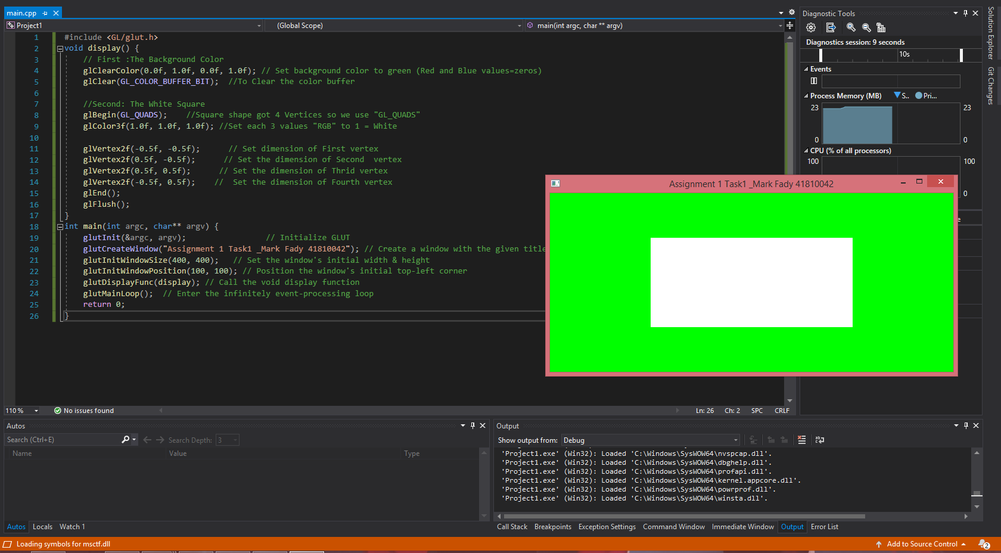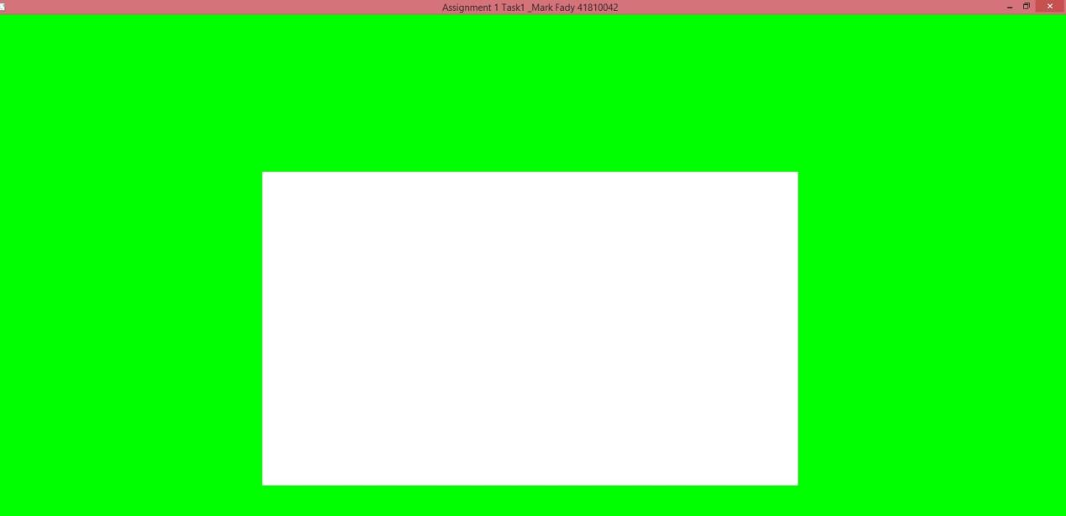

Documentation for **TASK2**

**----------------------------------**

* As it required to set the background color to black ,So we need to insert zero values to (Red,Green and Blue) , then clear the color buffer.
* Second Requirement is to set Width of each line to 3 , Before starting to implement lines , we use “glLineWidth();” Function and take argument with float we set it to 3 for sure.
* Third step is it to start implementing lines to make a shape of square using “GL_LINE_LOOP” in this case it is better than “GL_LINES” Because We need to make a shape with connected vertices and in this function the end points double back to each other ,so first point will automatically connected to end point.
* Here we need to set color for each line .As it required in the shape all lines are red so we need to put zero values to (Green and Blue) and put 1 value to (Red) to display it.
* We use “GL_LINE_LOOP” two times , First one to implement the shape with four lines with their color(Red) .Second one is to implement the two Diagonals with (Red) Color using only two lines
* First Diagonal Created by line connected by 2 vertices .First Vertex (Top Left) X=Negative , Y=Positive and second vertex (Bottom Right) X=Positive ,Y=Negative.
* Second Diagonal Created by line connected by 2 vertices.First Vertex(Top Right) X=Positive , Y=Positive and second vertex (Bottom Left) X=Negative ,Y=Negative

**Output Screenshots**

